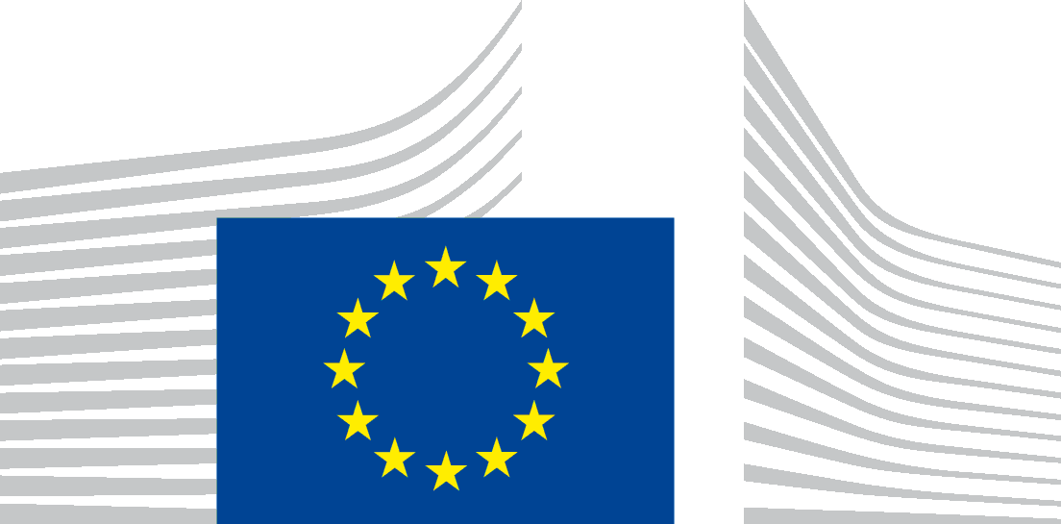 | EUROPEAN COMMISSION  DIRECTORATE-GENERAL FOR MARITIME AFFAIRS AND FISHERIES  FISHERIES POLICY MEDITERRANEAN AND BLACK SEA  CFP AND STRUCTURAL SUPPORT POLICY DEVELOPMENT AND COORDINATION

Inter-Advisory Councils (Inter-ACs) meeting 2021
18 January 2021
from 14:30 to 18:30

Virtual meeting (via INTERACTIO)
Simultaneous interpretation : From FR-EN-IT-ES-BG-RO-
into FR-EN-IT-ES-BG-RO-

Agenda

Participants: Advisory Councils, Commission (DG Maritime Affairs and Fisheries), observers from the Member States and from the European Parliament
Chair: Lena Andersson Pench
14:30 – 14:45 | Opening remarks – Director General Ms Vitcheva
14:45 –16:30 | How to improve the ACs’ performance and functioning?  2.1. Presentation of good practices and ideas by Advisory Councils  2.1.1. Gonçalo Carvalho, PELAC  2.1.2. Esben Sverdrup-Jensen, BSAC  2.1.3. Kenn Skau Fischer, NSAC  2.1.4. Alessandro Buzzi, MEDAC  2.1.5. Pedro Reis Santos, MAC  2.1.6. Alexandre Rodríguez, LDAC  2. Exchange of views  3. Conclusion and next steps by the Commission
16:30 – 17:00 | Coffee break
17:00 – 18:15 | Key developments on important files  State of play of the implementation and revision of the Control Regulation (Francesca Arena)  EU Multi-annual Programme for data collection and report on the Data Collection Framework implementation and functioning (Annette Hurrelmann)  New strategic guidelines for aquaculture, Farm to Fork Strategy, New algae initiative (Lorella de la Cruz Iglesias)  Blue Economy Communication (Isabelle Viallon)  Biodiversity Strategy: Technical Measures report and Action Plan (Valerie Tankink)
18:15 – 18:30 | AOB

